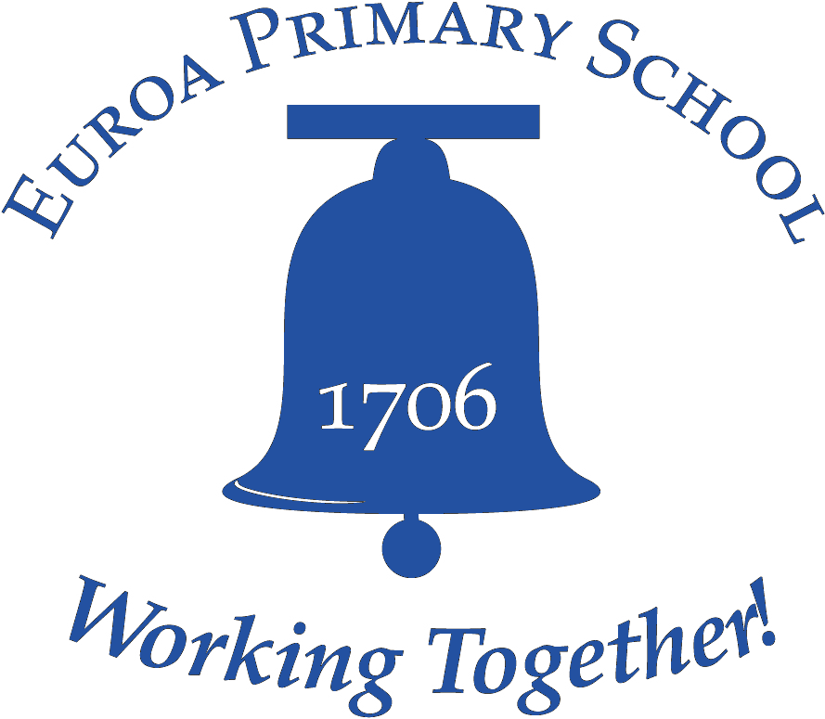

Child Safe
POLICY 2019

Aim
Euroa Primary School is committed to child safety. We want children to be safe, happy and empowered. We support and respect all children, as well as our staff and volunteers. We are committed to the safety, participation and empowerment of all children.
Rationale
We have zero tolerance of child abuse, and all allegations and safety concerns will be treated very seriously and consistently with our robust policies and procedures.
We have legal and moral obligations to contact authorities when we are worried about a child’s safety, which we follow rigorously.
Euroa Primary School is committed to preventing child abuse and identifying risks early, and removing and reducing these risks.
The school has robust human resources and recruitment practices for all staff and volunteers.
Our school is committed to regularly training and educating our staff and volunteers on child abuse risks.
We support and respect all children, as well as our staff and volunteers. We are committed to the cultural safety of Aboriginal children, the cultural safety of children from culturally, linguistically and gender diverse backgrounds, and to providing a safe environment for children with a disability.
We have specific policies, procedures and training in place that support our leadership team, staff and volunteers to achieve these commitments.
The child safe standards aim to protect children from abuse in organisations, including physical, violence, sexual offences, serious emotional or psychological abuse and serious neglect. For further explanation of the different types of child abuse, please see

An Overview of the Victorian child safe standards:
www.dhs.vic.gov.au/_data/assets/word_doc/0005/955598/Child-safe-standards_overview.doc
Implementation
Our Children
This policy is intended to empower children who are vital and active participants in our organisation. We involve them when making decisions, especially about matters that directly affect them. We listen to their views and respect what they have to say.
We promote diversity and tolerance in our organization, and people from all walks of life and cultural backgrounds are welcome.
In particular, we:
- Promote the cultural safety, participation and empowerment of Aboriginal children.
- Promote the cultural safety, participation and empowerment of children from culturally and/or linguistically diverse backgrounds.
- Ensure that children with a disability are safe and can participate equally.
- Promote the participation and empowerment of all students in our school community.
Our staff and volunteers
This policy guides our staff and volunteers on how to behave with children in our school.
All staff and volunteers must agree to abide by our Code of Conduct, which specifies the standards of conduct required when working with children.
Training and supervision
Training and education is important to ensure that everyone in our organization understands that child safety is everyone’s responsibility. Euroa Primary School takes responsibility to provide Professional Learning to staff around child safe policies and practices annually.
Our school culture aims for all staff and volunteers (in addition to parents/carers and children) to feel confident and comfortable in discussing any allegations of child abuse or child safety concerns. We train our staff to identify, assess, and minimise risks of child abuse and to detect potential signs of child abuse. Volunteers and casual staff are directed to seek support from mandated staff members.
For all jobs that require child connected work there will be an induction process providing explicit information about the job requirements, duties and responsibilities and the school’s child safe practices, including the Code of Conduct, Student Engagement and Wellbeing Policy.
We also support our staff and volunteers through ongoing supervision to: develop their skills to protect children from abuse; and promote the cultural safety of Aboriginal children, the cultural safety of children from linguistically and/or diverse backgrounds, and the safety of children with a disability.
New employees and volunteers will be supervised regularly to ensure they understand our school’s commitment to child safety and that everyone has a role to play in protecting children from abuse, as well as checking that their behaviour towards children is safe and appropriate (please refer to the school’s code of conduct to understand appropriate behaviour further). Any inappropriate behaviour will be reported through a member of the Leadership Team. This may include the Department of Health and Human Services and the Victoria Police, depending on the severity and urgency of the matter.
Recruitment
We take all reasonable steps to employ skilled people to work with children as per DET guidelines. We clearly demonstrate our commitment to child safety and an awareness of our social and legislative responsibilities. The school understands that when recruiting staff and volunteers we have ethical as well as legislative obligations. The school’s Statement of Values is shared with all staff.
We welcome applications from Aboriginal peoples, people from culturally and/or linguistically diverse backgrounds and people with disability.
All people engaged in child-related work, including volunteers, are required to hold a Working with Children Check and to provide evidence of this check. Please see the Working with children check website www.workingwithchildren.vic.gov.au for further information.
We carry out reference checks to ensure that we are recruiting the right people. VIT and WWC registration ensures that Police record check process is complete and we ensure that the registration is validated. We do retain our own records (but not the actual criminal record) if an applicant’s criminal history affected our decision making process.
If during the recruitment process a person’s records indicate a criminal history then the person will be given the opportunity to provide further information and context.
Fair procedures for personnel
The safety and wellbeing of children is our primary concern. We are also fair and just to personnel. The decisions we make when recruiting, assessing incidents, and undertaking disciplinary action will always be thorough, transparent, and based on evidence.
If an allegation of abuse or safety concern is raised, we provide updates to children and families on progress and any actions that we take when appropriate.
Privacy
All personal information considered or recorded will respect the privacy of the individuals involved, whether they be staff, volunteers, parents or children, unless there is a risk to someone’s safety. We have safeguards and practices in place to ensure any personal information is protected. Everyone is entitled to know how this information is recorded, what will be done with it, and who will have access to it.
Legislative responsibilities
Euroa Primary School takes our legal responsibilities seriously, including:
*Failure to disclose:
Reporting child sex abuse is a community-wide responsibility. All adults who form a reasonable belief that an adult has committed a sexual offence against a child under 16 have an obligation to report that information to the police. Failure to disclose the information to the police is a criminal offence except in limited circumstances, such as where the information has already been reported to the Child Protection or the child is over 16 when the belief is formed.
*Failure to protect:
Any staff member in a position of authority, who becomes aware that an adult associated with their Organisation (such as an employee, contractor, volunteer or visitor) poses a risk of sexual abuse to a child under the care, authority or supervision of the school, must take all reasonable steps to remove or reduce that risk. This may include, for example, removing the adult from the child-related work pending investigation. If a staff member in a position of authority fails to take reasonable steps in these circumstances, this may amount to a criminal offence. The offence applies only to adults in a position of authority within an Organisation, including Principals, senior school staff, regional directors and other senior managers.
Risk management
In Victoria, organisations are required to protect children when a risk is identified (see information about failure to protect above). In addition to general occupational health and safety risks, we proactively manage risks of abuse to our children.
We have risk management strategies in place to identify, assess, and take steps to minimise child abuse risks, which include risks posed by physical environments (for example, any doors that can lock), and online environments (please refer to the ICT Policy.)
Allegations, concerns and complaints
Euroa Primary School takes all allegations seriously and has practices in place to investigate thoroughly and quickly. Our staff and volunteers are trained to deal appropriately with allegations.
We work to ensure all children, families, staff and volunteers know what to do and who to tell if they observe abuse or are a victim, and if they notice inappropriate behaviour.
We all have a responsibility to report an allegation of abuse if we have a reasonable belief that an incident took place (see information about failure to disclose).
If an adult has a reasonable belief that an incident has occurred, then they must report the incident. Factors contributing to reasonable belief may be:
- A child states they or someone they know has been abused (noting that sometimes the child may in fact be referring to themselves).
- Behaviour consistent with that of an abuse victim is observed.
- Someone else has raised a suspicion of abuse but is unwilling to report it.
- Observing suspicious behaviour.

Related Documents
Ref: Department of Education and Training – Child Protection Reporting Obligations
http://www.education.vic.gov.au/school/principals/spag/safety/Pages/childprotection.aspx
Department of Health and Human Services
http://www.dhs.vic.gov.au/about-the-department/documents-and-resources/policies-guidelines-and-legislation/child-safe-standards-resources
For definitions of key terms, please see
An Overview of the Victorian child safe standards:
www.dhs.vic.gov.au/_data/assets/word_doc/0005/955598/Child-safe-standards_overview.doc
Evaluation
This policy will be reviewed every two years and following significant incidents if they occur. We will ensure that families and children have the opportunity to contribute. Where possible we do our best work with local Aboriginal communities, culturally and/or linguistically diverse communities and people with a disability.

This policy was last ratified by School Council on.... February 2019

